Physical link to the territory

Topography and Slope

Batangas Province’s terrain is mostly composed of elevated lands, small low flat lands, rolling hills and numerous mountains. Elevated lands can be found in different municipalities of Malvar, Mataasnakahoy, San Jose and the cities of Lipa, Tanauan and Sto. Tomas. Lowland rice culture relatively can adapt in small low flat lands in the municipalities of Padre Garcia and some portions of Rosario, Taysan, Lemery, Calaca, Lian, San Juan and Nasugbu. Lands that are good for production forest and considered as rolling hills are found in Rosario, Lemery, Calaca, Lian, San Juan, San Luis, Tuy and Agoncillo. The land topography of Cuenca, Calatagan, Balayan, Ibaan, Bauan, San Pascual, Taal, San Nicolas, Sta. Teresita, Alitagtag and Batangas City are gently rolling with some mountains. They are often utilized for coconut plantations and agro-forestry development and the like.

Some parts of mountainous municipalities of Lobo, Mabini, Tingloy, Laurel and Talisay are considered protected areas. Furthermore, prominent mountains in the province are Lobo Mountains in Lobo, Batulao in Nasugbu, Panay in Mabini, Makulot in Cuenca, Banoy and Pinamucan in Batangas City, Mt. Malarayat Forest Reserve and Susong Dalaga in Lipa City, San Pedrino in Southwestern Balayan, Los Picos and Pico de Loro in Nasugbu and Compradia located between San Juan and Rosario. Batangas shares with Laguna and Quezon, with Mt. Makiling, and Mt. Malipunyo, and Tagaytay Ridge with Tagaytay City. Generally, Batangas has a rolling terrain with almost fifty percent (50%) of its land area having a grade of less than 15°. Slopes can be found along the shores of Verde Island Passage and the shores of Taal Lake. The central part of the province is Mt. Makulot with a summit of 957 meters above sea level.

Shown below is a detailed table of the distribution of Provincial Land Resources on Crop Suitability based on slope categories.

Table __. Slope Categories, Area, Description and Crop Suitability

Range (%) | Area (ha.) | Description | Crop Suitability
0 – 3 | 25,253 | Level to nearly level | Irrigated/Paddy Fishpond
3 – 8 | 54,624 | Gently sloping to undulating | Annual cultivated crops
8 – 18 | 8,490 | Moderately sloppy to rolling | Perennial tree & vine crops
18 – 30 | 12,810 | Strongly sloping to moderately steep | Plantation forest
30 – 50 | 17,750 | Steep hills and mountains | Production forest
More than 50 | 87,654 | Very steep hills | Forest reserve mountains
Socio Economic and Physical Profile (SEPP), 2020

Batangas Province’s Slope Map designates what municipalities are level to gently sloping, gently sloping to undulating, undulating to rolling, rolling to hilly, hilly to steepy hilly and steepy hilly to mountainous.

Irrigated Land - Land serviced by natural irrigation or man - made irrigation facilities. These include lands where water is not readily available as existing irrigation facilities need rehabilitation or upgrading or where irrigation water is not available year-round.

Fishpond - A land-based facility enclosed with earthen or stone material to impound water for growing fish.

Annual Cultivated Crops - These are production areas devoted to sugarcane, corn, peanuts, and vegetables like eggplants, squash, mustard and root crops such as cassava, gabi, ube, and sweet potato.

Perennial Tree & Vine Crops - Plant or trees that last for more than two growing seasons, either dying back after each season or growing continuously.

Plantation forest - Generally intended for the production of timber and pulpwood increase the total area of forest worldwide.

Production forest - Production forests are forestlands utilized for timber production and non-timber uses. This can either be grassland, secondary forest or logged over areas which includes tenured forest land wherein utilization of forest resources in the area are regulated and well managed.

Forest Reserve Mountains - Forest lands that have been reserved by the President of the Philippines for any specific purpose or purposes.

As shown in the Table, major areas that are found to be Suitable to Irrigated Rice (SIR) land use are located in the municipalities of Balayan, Lemery, Lian, Nasugbu, Rosario, San Juan and Taysan, while minor areas are found in Lobo, Padre Garcia, Calatagan, Laurel and Calaca. These are low lying areas where irrigation water is abundant and can sustain rice crop production, if properly developed and maintained.

Municipalities that are usually found near the seashore or adjacent to river areas are considered to be suitable to Fishpond Production. These are the areas from Balayan, Calatagan, Lian, Lobo, Nasugbu, San Juan and Batangas City.

Moreover, the largest land area found Suitable to annual Cultivated Crops (SCC) which are generally devoted and planted to sugarcane crops can be found in western part of Batangas and a few number of hectares are situated in the eastern part of the Province.

Perennial Trees and Vines (PTV) production is identified and found to be suitable in Balete, Bauan, Cuenca, Malvar, Rosario, San Jose, San Pascual, and Cities of Tanauan, Batangas and Lipa.

There are minimal areas that are found to be suitable for pasture land purposes because of less availability of grass during the dry season. These are located at Calatagan and Tuy which are intermittently distributed by patches somewhere in Lipa City.

Furthermore, areas found to be suitable for forest plantation in the province are usually found and located at Laurel, Balayan, Lemery, Lian, Nasugbu, Lobo, Talisay, Agoncillo, Bauan, Mabini, Malvar, Rosario, San Juan, San Luis, Tingloy and Cities of Tanauan, Batangas and Lipa. Aside from plantation forest, areas suitable to production forest purposely for the production of timber are frequently found in Agoncillo, Alitagtag, Bauan, Lemery, Lobo, Mabini, Mataasnakahoy, San Jose, San Juan, San Luis, Taysan, Tingloy, Tuy Tingloy and Cities of Tanauan, Batangas and Lipa.

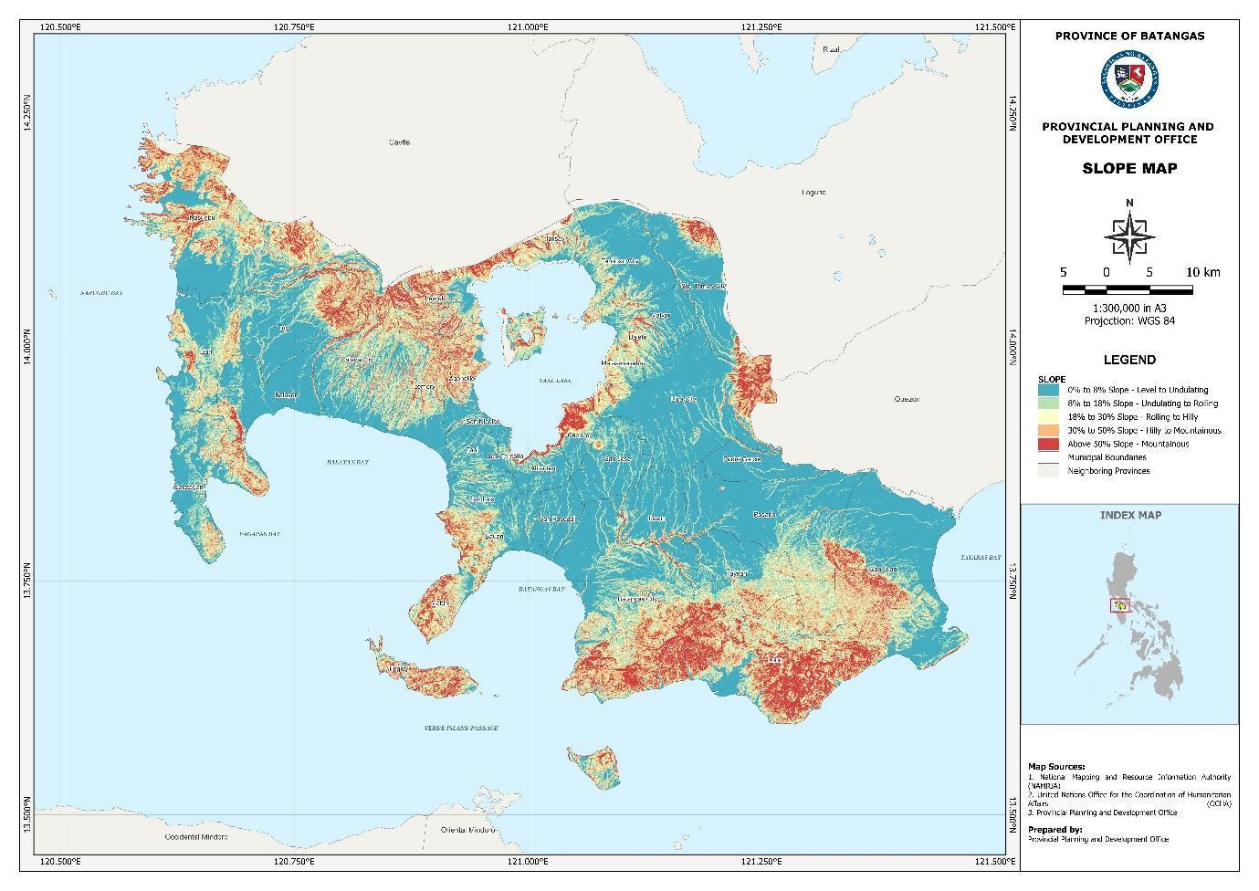
Figure _. Slope Map

Soil Physiography

Batangas Province is endowed with rich, volcanic soil above par in quality and easy to cultivate. The geographical formation of soil consists mostly of water-laid volcanic tuff. The tuffaceous formation covers the agricultural regions.

The characterization and classification of the different types of soils are according to the landforms and landscapes and delineated in the maps by Bureau of Soils and Water Management (BSWM) under the land resources evaluation project.

Table __. Batangas Major Land Form and Uses

Land Forms | Municipalities / Cities Commonly Covered | Present Use | Crop / Land Use Suitability
Lowland-Wetland | Nasugbu, Lian, Calatagan, Lobo & San Juan | Fishpond, Mangrove, Nipa | Fishpond
 |  |  | Mangrove
 |  |  | Nipa
Lowland Alluvial | Balayan, Lemery, Laurel, Balete, San Juan, Talisay | Rice, Sugar diversified | Rice and Annual Crops
 | Santo Tomas, Tanauan City, San Juan, Lipa City, Balayan & Nasugbu | Rice, Sugar, Coco tree | Annual Crops
Lowland-Residual |  | Diversified Crops
 | Calaca, Sto. Tomas, Tuy & Balayan
Upland |  |  | Perennial trees & Vine crops
Source: Batangas Socio-Economic Profile

Table __. Soil Type Distribution, 2020

CITY/MUNICIPALITY | CLAY | LOAM | SANDY
- Batangas City |  | x
- Calaca City |  | x | x
- Lipa City |  | x
- Tanauan City |  | x
- Sto. Tomas City |  | x
- Agoncillo |  | x
- Alitagtag |  | x
- Balayan |  | x
- Balete | x | x | x
- Bauan |  | x
- Calatagan | x | x | x
- Cuenca |  | x
- Ibaan | x | x
- Laurel |  | x
- Lemery |  | x | x
- Lian | x | x | x
- Lobo | x | x
- Mabini |  | x
- Malvar |  | x
- Mataasnakahoy |  | x
- Nasugbu | x | x | x
- Padre Garcia | x | x
- Rosario | x | x
- San Jose |  | x
- San Juan | x | x
- San Luis |  | x
- San Nicolas |  | x
- San Pascual |  | x
- Sta. Teresita |  | x
- Taal |  | x
- Talisay |  | x
- Taysan | x | x
- Tingloy | x | x | x
- Tuy |  | x

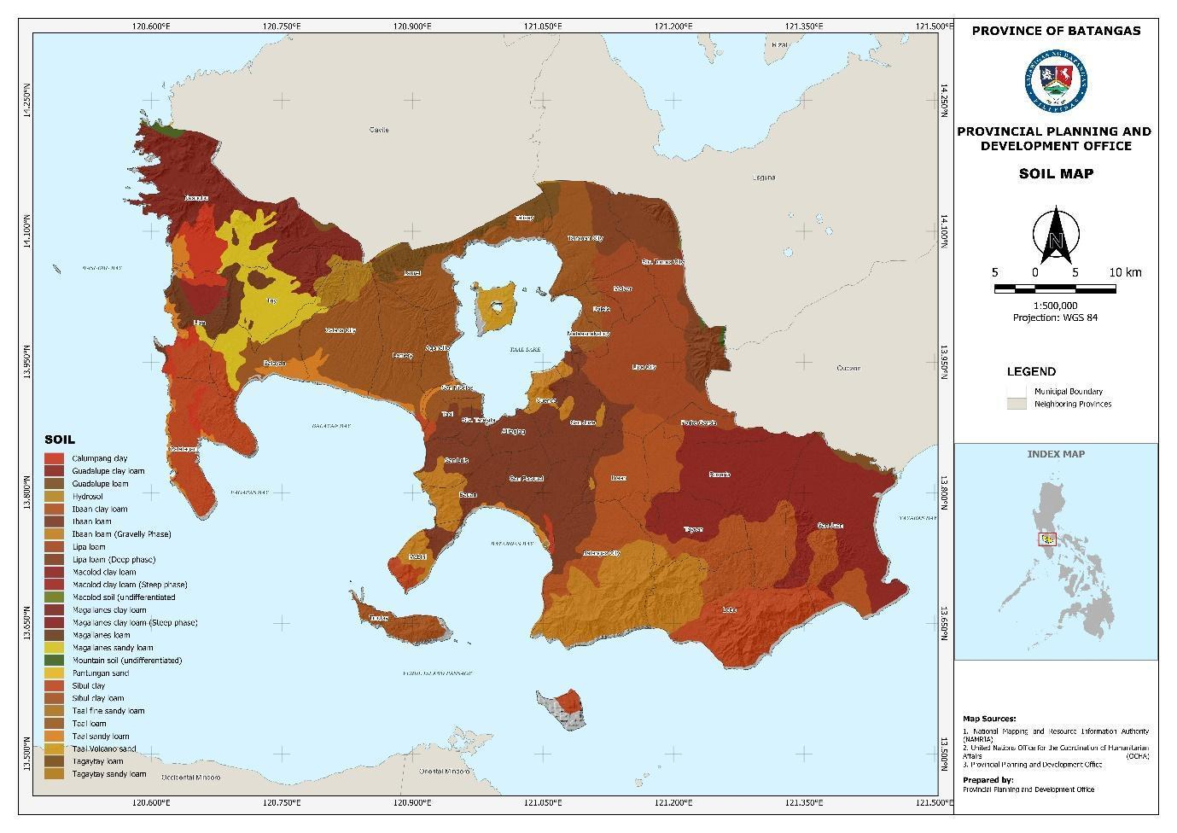

Figure _. Soil Map

Soil Suitability for Liberica Coffee

Soil suitability analysis plays a vital role in maximizing land production and maintaining environmental sustainability by identifying lands that are most suitable for specific crops. It provides information on the potential and constraints of an area, a prerequisite for optimum crop production.
Liberica coffee requires land suitability criteria to support its growth and productivity. If an area has infertile soil conditions and has a climate that is not in accordance with the criteria for growing Liberica coffee, then several alternative solutions are needed to determine the suitability of land in that area.

The Vulnerability and Suitability Analysis (VSA), a scientific tool developed by the Bureau of Soils and Water Management (BSWM), is being used as a guide to determine the vulnerability and suitability of a particular area that could affect the production of Liberica coffee. VSA can assess the suitability of the total land area for growing Liberica coffee using five (5) agronomic factors as criteria namely: elevation, precipitation, temperature, soil pH, and soil texture.

Using VSA, the map below shows which area in the province is the most suitable for planting Liberica coffee. As shown, almost 90% of the province is suitable for growing Liberica coffee. The cities of Lipa and Tanauan, the municipalities of San Juan, Malvar, Lian, Bauan and Sta. Teresita is the most highly suitable area for such a commodity; while the least suitable areas are the municipalities of Lobo, San Luis, Lemery and Laurel.

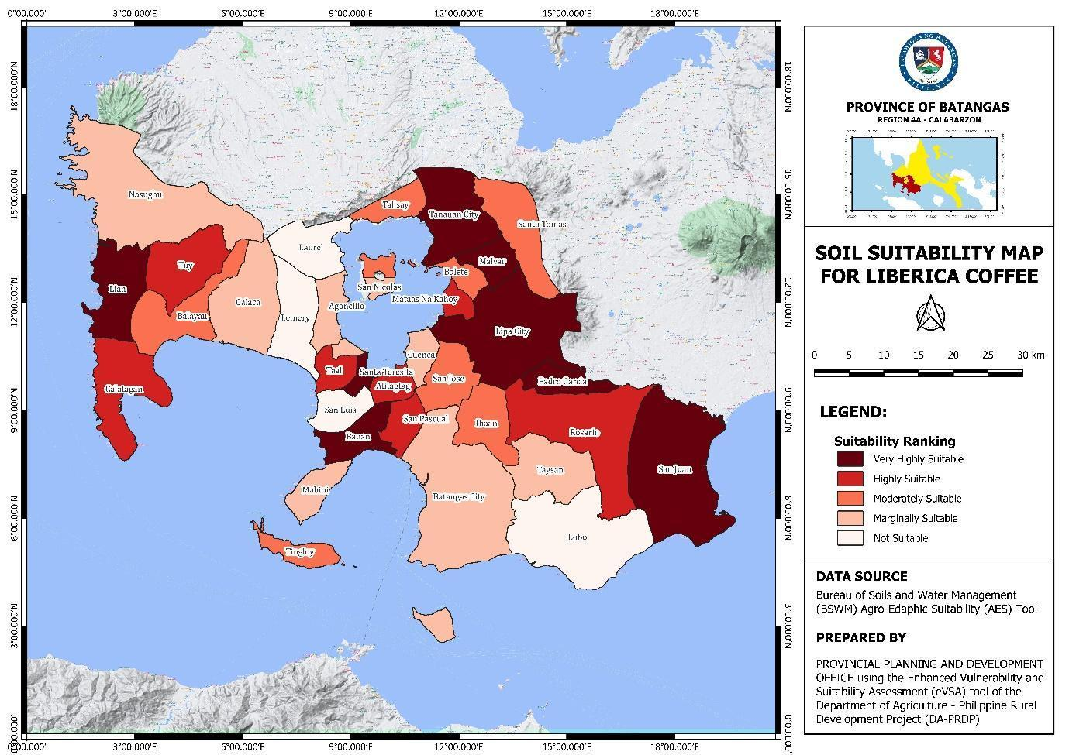

Figure _. Soil Suitability Map

Climate

Batangas has two types of climate – Type I and Type III (see Map 35). Type I has two seasons: dry from the months of November to April and wet during the rest of the year. Meanwhile, Type III has no very pronounced maximum rain period with a dry season lasting only from one to three months, either during the period from December to February or from March to May. This type resembles types I since it has short dry season. Generally, the climate of the province is cool and air is humid. However, the climate varies according to one's' topography and locality. May is usually the hottest month and the coldest month is February.

The region west of the imaginary line running northeast/southwest from the foothills of Mt. Pinamucan in Batangas City and Mt. Malipunyo at the Batangas-Laguna Boundary falls under Type I. Moreover, municipalities of Agoncillo, Alitagtag, Balayan, Balete, Bauan, Calaca, Calatagan, Cuenca, Ibaan, Laurel, Lemery, Lian, Mabini, Malvar, Mataasnakahoy, Nasugbu, San Jose, San Luis, San Nicolas, San Pascual, Sta. Teresita, Taal, Talisay, Tanauan, Tingloy, Tuy and half portion of Lobo, Padre Garcia, Rosario and Taysan; and the cities of Batangas, Sto. Tomas and Lipa also falls under this type.
Verde Island and the municipality of San Juan and some portions of Lobo, Padre Garcia, Rosario and Taysan falls under Type III.
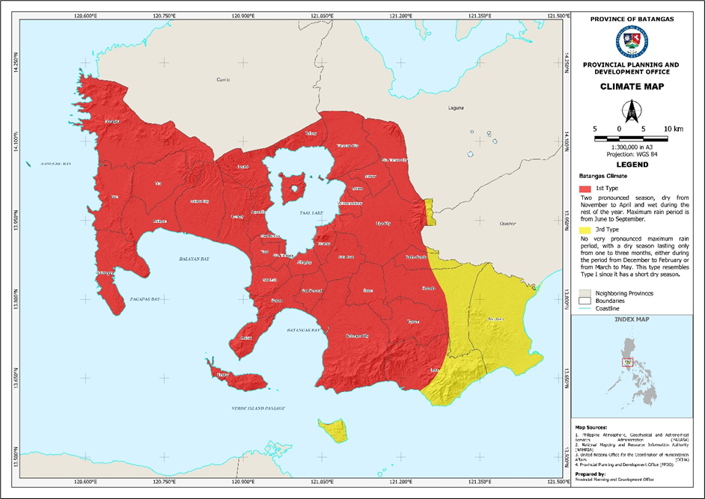
Figure __. Climate Map

Historical temperature record of the province from 1971-2000 is shown in the foregoing table:

Table __. Historical Average Temperature Record -1971 to 2000

Period  (Months) | Average Temperature (in °C)
December – February | 24.2
March – May | 26.5
June – August | 25.9
September – November | 25.6
Source: Detailed Guidelines for Mainstreaming DRA and CCVA in the PDPFP,
Dr. Candido A Cabrido, Jr. National Consultant, NEDA/CCA Mainstreming Project

As projected, that there will be more frequent hot temperatures in the country with almost all areas getting warmer and the dry seasons becoming drier. There will be an increase in the number of dry days nationwide in 2020 and 2050. Accordingly, temperature of more than 350C may be felt for 8,010 days, and within the years 2006 to 2035, there will be 6,081 dry days. However, the years 2036-2065 will see lesser dry days with 6,049 and more days with temperature of more than 350C, numbering about 8,016.

When there is a change of temperatures, El Niño and La Niña occur. El Niño Southern Oscillation (ENSO) is a large-scale natural fluctuation of the global climate system resulting from the interactions between the ocean and atmosphere in the Central and Eastern Equatorial Pacific (CEEP). El Niño is the unusual warming in the CEEP resulting to prolonged dry season, while La Niña is the unusual cooling in the CEEP resulting to prolonged rainy season. This climate cause heavy rains in some part of the Philippines. During a period of La Niña, the sea surface temperature across the equatorial Eastern Central Pacific Ocean will be lower than normal by 3–5 °C.

Both effects of El Niño and La Niña are very important for the climate and the weather conditions in the Philippines. Simply because El Niño bring dry weather and even droughts while La Niña stands for rainy weather and floods. Impacts are on stream flow, dam operation, water allocation, domestic water supply, irrigation, hydropower allocation, depth and recharge of aquifers, water quality, watersheds and fishery. Economy, environment and communities of the four cities and 30 municipalities are all vulnerable to the variability of precipitation, frequency of typhoons, sea level rise and the risk of more droughts, floods, heat waves, forest and grassland fires brought about by the El Niño and La Niña phenomena.
Top LGUs with high exposure to flooding are the municipalities of Calatagan, Balayan and Batangas City. Calatagan having the biggest area exposure has more than half of its total land area (51 percent) or an estimated 57.092 square kilometers out of 111.97 square kilometers. The overflow of Santiago River brings threats of flooding to Barangay Lucsuhin the most. This is caused by siltation and the increase in the built-up area aggravated by high tide and extreme water pressure during heavy rains.
On the other hand, drought is an extended period when a region receives a deficiency in its water supply, whether atmospheric, surface or ground water. A drought can last for months or years, or may be declared after as few as 15 days. Generally, this occurs when a region receives consistently below average precipitation. It can have a substantial impact on the ecosystem and agriculture of the affected region. Although droughts can persist for several years, even a short, intense drought can cause significant damage and harm to the local economy.
Based on the Drought Vulnerability Index Map, municipalities that are vulnerable to drought are San Luis, Sta. Teresita, San Luis and Tingloy.
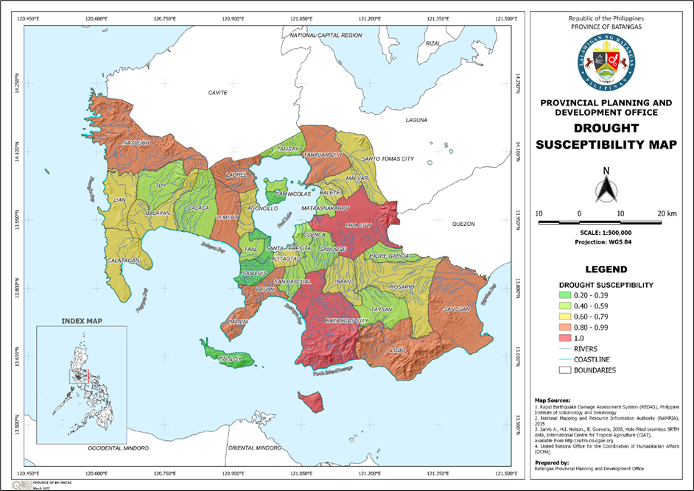
Figure __. Drought Vulnerability Index Map

Definition of the Geographical Area

The delimited territory (geographical area) of the Batangas Kapeng Barako encompasses the entire province of Batangas, consisting of the 5 cities and 29 municipalities.

Organization
The following figure shows the organizational chart of the collective group, Batangas Coffee Farmers Federation (BaCoFFed)
ARNOLD B. MALBATAAN
President

GEMMA BARLAAN
Vice President

JULIET A. BENEDICTO
Secretary

JEFFREY MENDIOLA
Treasurer

CASIANO DOTADO
Auditor

MARIO GARCIA
Board of Director

MARIA CORAZON R. MAULION
Board of Director
BIENVENIDO HERNANDEZ
Board of Director

